Abstract— A simple mechanistical mathematical model is used to investigate hidden properties of hemodynamics in portal hypertension.
Underestimating Portal Hypertension severity due to collateral shunts
Filip Jezek, Nikhilesh R. Mazumder, Dan A. Beard
Clinical Relevance— The severity of disease in cirrhosis centers on the pressure drop across the liver, however the influence of other disease factors on this pressure have not been previously modeled.

introduction
The natural history of cirrhosis is marked by progressive alterations in portal circulation ranging from asymptomatic portal vein pressure increases to life threatening decompensating events such as variceal bleeding and ascites [1]. A rudimentary measure used to assess disease severity in clinical trials is the hepatic venous pressure gradient (HVPG). Despite its widespread use, HVPG is influenced by volume flow rate in the portal vein (PV), and proportion of portal flow through collaterals. Thus, a more complete hemodynamic analysis of the portal system could assist clinicians in understanding the mechanisms driving portal hypertension and its progression. However, such a theoretical framework does not exist. The objective of this study was to apply a novel computational model of liver disease, cirrhosis, and clinically significant portal hypertension to demonstrate the hidden mechanisms behind the HVPG.

methods
We have employed 0D modeling of the isolated splanchnic hemodynamics (fig 1). We have extended the steady state Levitt’s and Levitt’s model [2] to calculate the steady state ascites pressure, HVPG and PPV with nominal inflow rate of 1L/min. This model consists of resistive components in series (intestinal arteries and veins, liver, hepatic vein) and a model of the peritoneal compartment. In patients with portal hypertension there are often collateral shunts from portal vein into the vena cava. We hypothesize that the elasticity of the venous wall, together with long-term remodeling, causes otherwise tiny vessels to grow in diameter as a function of portal pressure. With increasing luminal diameter, a large amount of portal vein flow is shunted, decreasing the HVPG, masking the true liver resistance. The shunt is modeled as a linear resistance given by Hagen-Poiseulle’s law, with variable radius r, expressed from = =, where p is the transmural mid-point pressure and C is an arbitral compliance parameter.
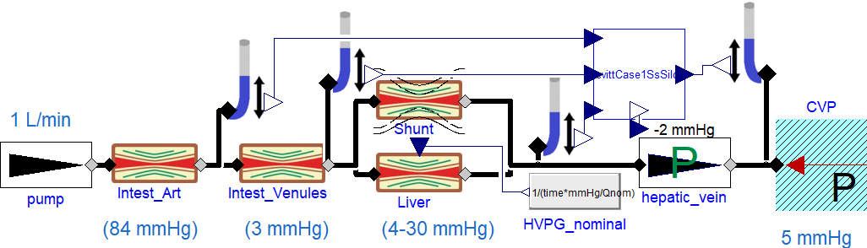
- Model schematics in Modelica language
Detailed description is at [3]. We then compared the portal vein pressure (PPV) and HVPG at increasing liver resistance, characterized by the nominal HVPG (NHVPG) (as if without shunts), with a fixed-diameter shunt, and with our novel compliant shunt.

RESULT, DISCUSSION & CONCLUSION
Fig. 2 shows the underestimation of HVPG with respect to the increasing liver resistance. At NHVPG of 30mmHg, the compliant shunt effectively limits both the apparent HVPG and PPV, by shunting up to half the flow (not shown). The resulting shunt dilation may however lead to life-threatening variceal ruptures.
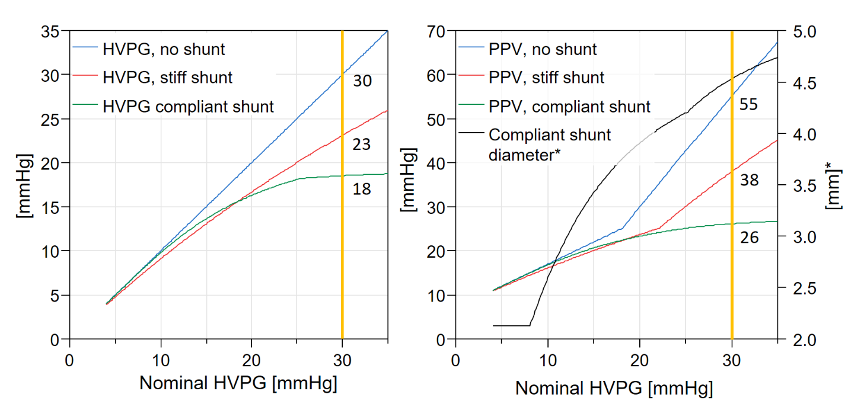
- Increase of HVPG and PPV for nominal (no shunts), stiff and novel compliant shunt model.
This simple model demonstrates how shunts may falsely lower HVPG, potentially falsely reassuring physicians about the severity of liver disease. Despite the clinical utility of HVPG, a more comprehensive hemodynamic model of portal hypertension is needed to fully grasp the severity of the hemodynamic failure. The developed modeling framework is presented with additional interventions (e.g. TIPSS, bodily regulations etc), The model source codes as well as detailed model documentation is publicly available at [3].
References
- G. D’Amico, G. Garcia-Tsao, and L. Pagliaro, “Natural history and prognostic indicators of survival in cirrhosis: a systematic review of 118 studies,” J. Hepatol., vol. 44, no. 1, pp. 217–231, Jan. 2006.
- D. G. Levitt and M. D. Levitt, “Quantitative modeling of the physiology of ascites in portal hypertension,” BMC Gastroenterol., 2012.
- F. Ježek, Ascites: ascites modeling. Github. Accessed: Apr. 04, 2022. [Online]. Available: https://github.com/filip-jezek/Ascites

  F. J. and D.A.B. are with the Department of Molecular and Integrative Physiology and N. R. M.. is with the Division of Gastroenterology and Hepatology, both at University of Michigan, Ann Arbor, MI, USA; e-mail: fjezek@ umich.edu.

